**Python Function** Odin Outsourcing

**How does function work-1?**

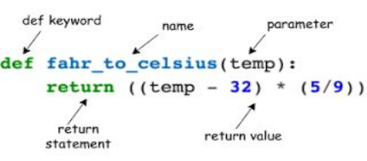

**How** 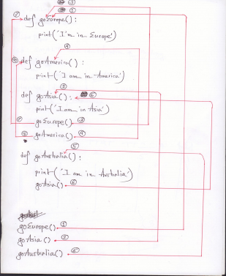

**does function work-2?**

Code: https://paste.ubuntu.com/ p/PKt8dnXCZq

**How does function work-3?**

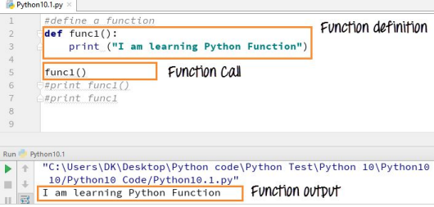

**How does function work-4?**

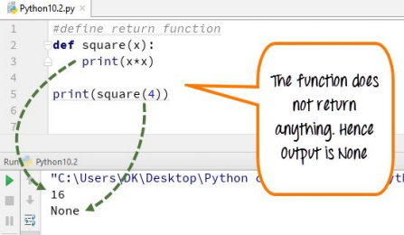

**How does function work-5?**

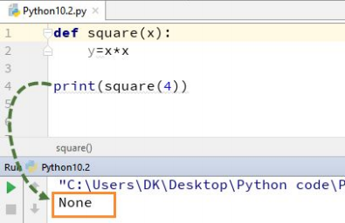

**How does function work-6?**

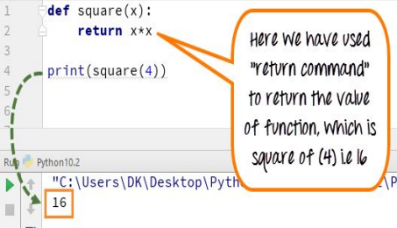

**How does function work-7?**

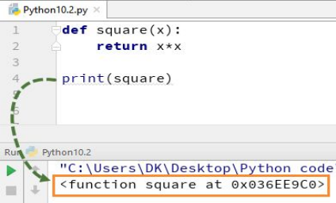

**How does function work-8?**

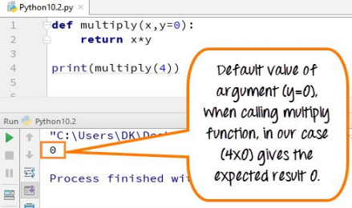

**How does function work-9?**

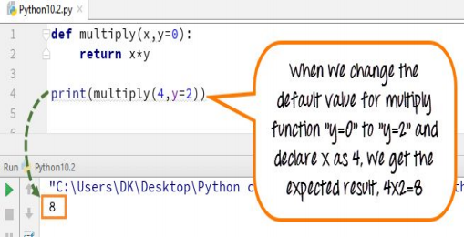

**How does function work-10?**

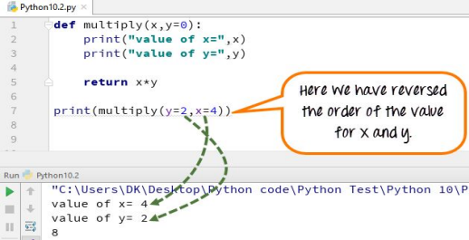

**How does function work-11?**

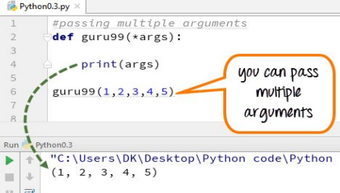

**Learning Resources:**

1. Function-1: https://www.guru99.com/functions-in-python.html ( ***** ) 2. Function-2: https://introcs.cs.princeton.edu/python/21function/ 3. Function-3: https://python.swaroopch.com/functions.html 4. Inner Function:

https://realpython.com/inner-functions-what-are-they-good-for/

**Contract your instructor!**

Find Me: http://rafsanjani.pythonanywhere.com/contact

Course Website: https://mrzResearchArena.github.io/Big-Data-using-Python

Thank you!